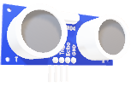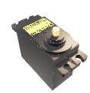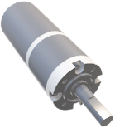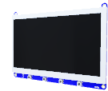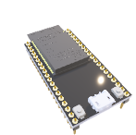

Project Objective:

2. Lane Departure Warning (LDW):

Ultrasonic Sensor

Servo Motor

DC Motor

7-inch LCD Screen

NVIDIA Jetson Nano

ESP32

Astra Pro Depth Camera

* LDW alerts drivers when their vehicle unintentionally drifts out of their lane.
* Implementation:

1. We use NVIDIA Jetson Nano as our main MCU responsible for our ML, Astra Pro Plus Depth camera as our RGB sensor.
2. We use Python, Python’s libraries such as: OpenCV, and NumPy to implement this feature.

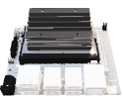

Components

* YOLOv5
* NumPy.
* CUDA.
* Linux.
* C++.
* Python.
* OpenCV
* TensorRT.

Software Tools:

ADAS can work an important role in many factors to reduce the number of crashes cases as possible using the power of sensors and Machine learning algorithms to analyze the environment around the vehicle and take the required action in the suitable time, these factors are:

1. Blind Spot Detection System.
2. Lane Departure.
3. Adaptive Cruise Control.
4. Bump Detection.
5. Traffic Sign Recognition.

2

* ACC that adjusts the vehicle's speed automatically to maintain a safe distance from the vehicle ahead.
* Implementation:

1. We use NVIDIA Jetson Nano, Astra Pro Plus Depth camera as RGBD sensor and D for Depth.
2. We use Custom AI Model based on YOLOv5 to detect different vehicles on the road, we use Python, TensorRT, and OpenCV.

3. Adaptive Cruise Control (ACC):

Features:

1. Blind Spot Detection (BSD):

* BSD technology helps drivers identify vehicles in their blind spots and alerts them to avoid dangerous maneuvers.
* Implementation:

1. We use ESP32 as MCU, and Ultrasonic sensor.
2. We use C++ to program this feature.

4

3

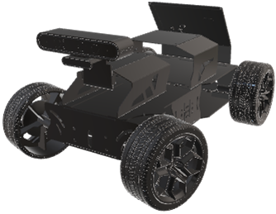

The companies VALEO, Magneti Marelli GmbH, Vector, SEITech Solutions, and Hella specialize in developing automotive software and providing modem and smart technological systems for vehicles.

Project Application:

* BD systems are equipped to detect and alert drivers of speed bumps and other road irregularities.
* Implementation:

1. We use NVIDIA Jetson Nano, Astra Pro Plus Depth camera as RGBD sensor.
2. We use Custom AI Model based on YOLOv5 to detect different Bumps on the road, we use Python, TensorRT, and OpenCV.

4. Bump Detection (BD):



Our ADAS project significantly enhances automotive safety and driving experience by integrating technologies such as blind-spot detection, lane departure warning, traffic sign recognition, adaptive cruise control, and bump detection. Through extensive research, development, and testing, we have addressed key safety challenges and established a foundation for future advancements in driver assistance. This project demonstrates the trans-formative potential of technology to im-prove road safety, efficiency, and driving enjoyment globally.

For more information

Conclusion:

5

6

1

* TSR can interpret and display traffic signs to keep drivers informed about speed limits, no-entry signs, and more.
* Implementation:

1. We use NVIDIA Jetson Nano, Astra Pro Plus Depth camera as our RGB sensor.
2. We use Custom AI Model based on YOLOv5 to detect different Traffic Signs on the road, we use Python, TensorRT, and OpenCV.

5. Traffic sign Recognition (TSR):

The Academy of Scientific Research & Technology (ASRT)

Sponsor

Dr. Waleed Abd-Elshafi Ali Elshazly.

Dr. Mohamed Hussein

Supervisors

Team Members

Hatem Abdelhamid

Haneen Salah

Abdelrahman Amr

Abdelrahman Mohamed

Mahmoud Mohamed

Fesal Mohamed

Ahmed Mohamed

Toka Hamdy

Youssef Mohamed

Omar Hosny

**Advanced Driver Assistance System (ADAS)**

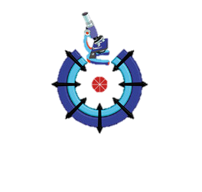

The Academy of Scientific Research & Technology (ASRT)

5

6

1

For more information